

19c grid installation for 2 Node RAC server
Oracle 19c database version

Project



DISCLAIMER

This document is strictly private, confidential and personal to its recipients and should not be copied, distributed or reproduced in whole or in part, nor passed to any third party.

Version history
Date | Version | Description | Author
2022-05-20 | 1.0 | Initial Version | Kinshuk Ajmera

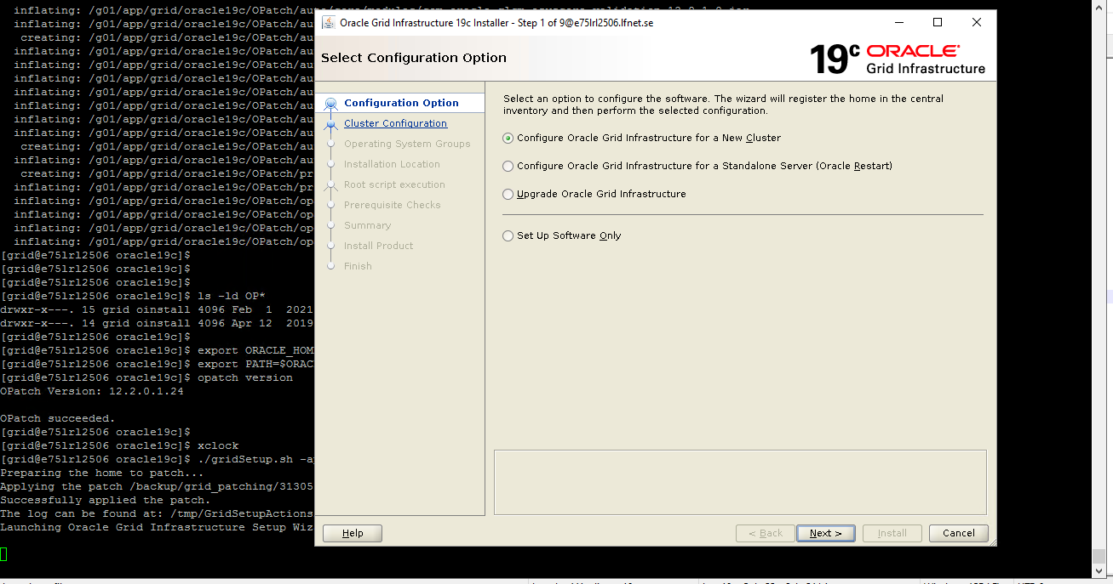

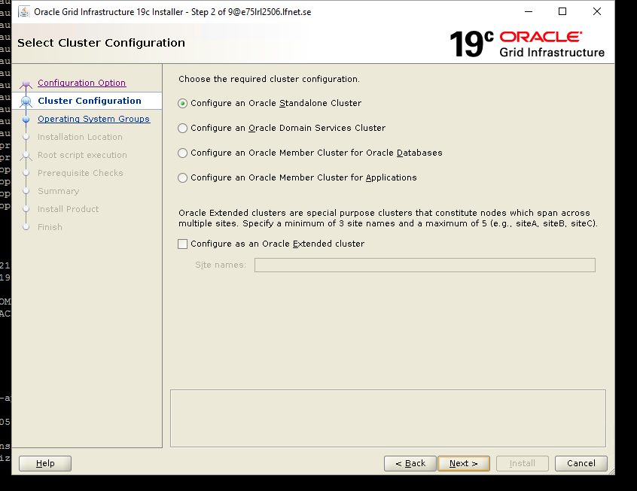

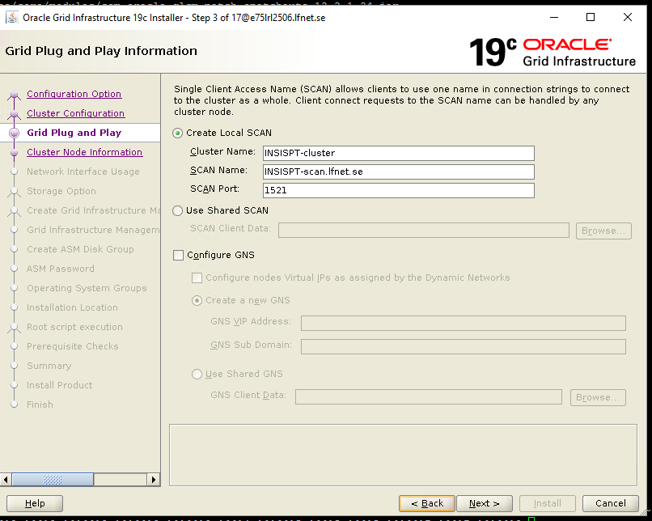
Give scan name in the above which is registered in DNS server. That scan name should be resolvable to three scan ip’s
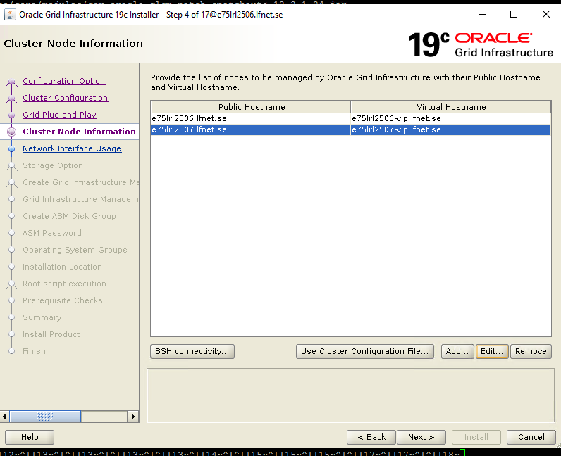
Add another node by clicking add button

Click ssh connectivity
Give grid password here – ’oracle’
Click test

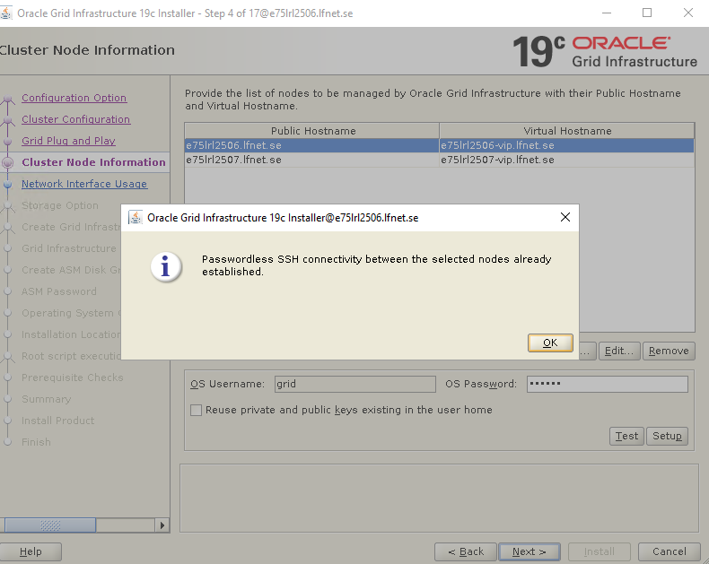

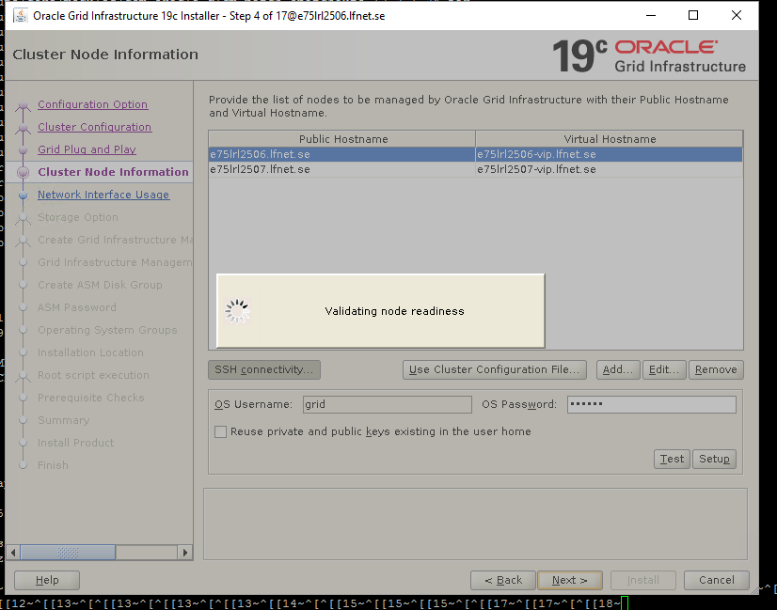

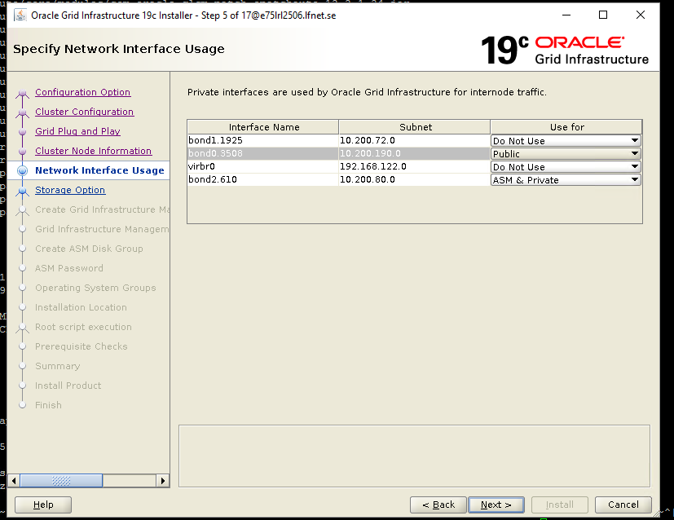

[u81c93@e75lrl2506 ~]$ cat /etc/hosts
127.0.0.1 localhost localhost.localdomain localhost4 localhost4.localdomain4
::1 localhost localhost.localdomain localhost6 localhost6.localdomain6
10.200.191.17 e75lrl2506.lfnet.se e75lrl2506
10.200.0.207 hmwbkpv1.hmgt.net hmwbkpv1
10.200.48.32 rhn8.hmgt.net rhn8
# Public IP
#10.200.191.17 e75lrl2506 e75lrl2506.lfnet.se
10.200.191.18 e75lrl2507 e75lrl2507.lfnet.se

# Private IP
10.200.80.171 e75lrl2506-priv e75lrl2506-priv.lfnet.se
10.200.80.172 e75lrl2507-priv e75lrl2507-priv.lfnet.se

# VIP address
10.200.191.21 e75lrl2506-vip e75lrl2506-vip.lfnet.se
10.200.191.22 e75lrl2507-vip e75lrl2507-vip.lfnet.se
[u81c93@e75lrl2506 ~]$

[u81c93@e75lrl2506 ~]$ ifconfig
bond0: flags=5187<UP,BROADCAST,RUNNING,MASTER,MULTICAST> mtu 1500
inet6 fe80::450:dbff:fed0:11b2 prefixlen 64 scopeid 0x20<link>
ether 06:50:db:d0:11:b2 txqueuelen 1000 (Ethernet)
RX packets 1419379 bytes 406289505 (387.4 MiB)
RX errors 0 dropped 0 overruns 0 frame 0
TX packets 3492463 bytes 3851413017 (3.5 GiB)
TX errors 0 dropped 2 overruns 0 carrier 0 collisions 0

bond1: flags=5187<UP,BROADCAST,RUNNING,MASTER,MULTICAST> mtu 1500
inet6 fe80::450:dbff:fed0:11b6 prefixlen 64 scopeid 0x20<link>
ether 06:50:db:d0:11:b6 txqueuelen 1000 (Ethernet)
RX packets 26111040 bytes 2133559829 (1.9 GiB)
RX errors 0 dropped 0 overruns 0 frame 0
TX packets 8491137 bytes 10903315985 (10.1 GiB)
TX errors 0 dropped 3 overruns 0 carrier 0 collisions 0

bond2: flags=5187<UP,BROADCAST,RUNNING,MASTER,MULTICAST> mtu 1500
inet6 fe80::450:dbff:fed0:11b7 prefixlen 64 scopeid 0x20<link>
ether 06:50:db:d0:11:b7 txqueuelen 1000 (Ethernet)
RX packets 1553038 bytes 409250004 (390.2 MiB)
RX errors 0 dropped 0 overruns 0 frame 0
TX packets 39384 bytes 5052522 (4.8 MiB)
TX errors 0 dropped 0 overruns 0 carrier 0 collisions 0

bond0.3508: flags=4163<UP,BROADCAST,RUNNING,MULTICAST> mtu 1500
inet 10.200.191.17 netmask 255.255.254.0 broadcast 10.200.191.255
inet6 fe80::a85b:594e:9b66:debb prefixlen 64 scopeid 0x20<link>
ether 06:50:db:d0:11:b2 txqueuelen 1000 (Ethernet)
RX packets 1227151 bytes 369824564 (352.6 MiB)
RX errors 0 dropped 0 overruns 0 frame 0
TX packets 1287007 bytes 3700279529 (3.4 GiB)
TX errors 0 dropped 0 overruns 0 carrier 0 collisions 0

bond1.1925: flags=4163<UP,BROADCAST,RUNNING,MULTICAST> mtu 1500
inet 10.200.72.130 netmask 255.255.252.0 broadcast 10.200.75.255
inet6 fe80::e7a4:df4b:a3fe:c1e2 prefixlen 64 scopeid 0x20<link>
ether 06:50:db:d0:11:b6 txqueuelen 1000 (Ethernet)
RX packets 14034046 bytes 942956790 (899.2 MiB)
RX errors 0 dropped 0 overruns 0 frame 0
TX packets 2235958 bytes 10493506053 (9.7 GiB)
TX errors 0 dropped 0 overruns 0 carrier 0 collisions 0

bond2.610: flags=4163<UP,BROADCAST,RUNNING,MULTICAST> mtu 1500
inet 10.200.80.171 netmask 255.255.255.0 broadcast 10.200.80.255
inet6 fe80::8216:a153:51ce:808b prefixlen 64 scopeid 0x20<link>
ether 06:50:db:d0:11:b7 txqueuelen 1000 (Ethernet)
RX packets 777235 bytes 187999194 (179.2 MiB)
RX errors 0 dropped 0 overruns 0 frame 0
TX packets 371 bytes 56064 (54.7 KiB)
TX errors 0 dropped 0 overruns 0 carrier 0 collisions 0

eno49: flags=6211<UP,BROADCAST,RUNNING,SLAVE,MULTICAST> mtu 1500
ether 06:50:db:d0:11:b2 txqueuelen 1000 (Ethernet)
RX packets 56171 bytes 3611102 (3.4 MiB)
RX errors 0 dropped 0 overruns 0 frame 0
TX packets 31068 bytes 3976704 (3.7 MiB)
TX errors 0 dropped 0 overruns 0 carrier 0 collisions 0
device interrupt 16 memory 0x93800000-93ffffff

eno50: flags=6211<UP,BROADCAST,RUNNING,SLAVE,MULTICAST> mtu 1500
ether 06:50:db:d0:11:b2 txqueuelen 1000 (Ethernet)
RX packets 1363208 bytes 402678403 (384.0 MiB)
RX errors 0 dropped 0 overruns 0 frame 0
TX packets 3461395 bytes 3847436313 (3.5 GiB)
TX errors 0 dropped 0 overruns 0 carrier 0 collisions 0
device interrupt 17 memory 0x94800000-94ffffff

eno51: flags=6211<UP,BROADCAST,RUNNING,SLAVE,MULTICAST> mtu 1500
ether 06:50:db:d0:11:b6 txqueuelen 1000 (Ethernet)
RX packets 12076450 bytes 902052981 (860.2 MiB)
RX errors 0 dropped 0 overruns 0 frame 0
TX packets 31068 bytes 3976704 (3.7 MiB)
TX errors 0 dropped 0 overruns 0 carrier 0 collisions 0
device interrupt 17 memory 0x95800000-95ffffff

eno52: flags=6211<UP,BROADCAST,RUNNING,SLAVE,MULTICAST> mtu 1500
ether 06:50:db:d0:11:b6 txqueuelen 1000 (Ethernet)
RX packets 14034590 bytes 1231506848 (1.1 GiB)
RX errors 0 dropped 0 overruns 0 frame 0
TX packets 8460069 bytes 10899339281 (10.1 GiB)
TX errors 0 dropped 0 overruns 0 carrier 0 collisions 0
device interrupt 18 memory 0x96800000-96ffffff

eno53: flags=6211<UP,BROADCAST,RUNNING,SLAVE,MULTICAST> mtu 1500
ether 06:50:db:d0:11:b7 txqueuelen 1000 (Ethernet)
RX packets 777230 bytes 205031040 (195.5 MiB)
RX errors 0 dropped 0 overruns 0 frame 0
TX packets 19880 bytes 2556010 (2.4 MiB)
TX errors 0 dropped 0 overruns 0 carrier 0 collisions 0
device interrupt 18 memory 0x39fff000000-39fff7fffff

eno54: flags=6211<UP,BROADCAST,RUNNING,SLAVE,MULTICAST> mtu 1500
ether 06:50:db:d0:11:b7 txqueuelen 1000 (Ethernet)
RX packets 775808 bytes 204218964 (194.7 MiB)
RX errors 0 dropped 0 overruns 0 frame 0
TX packets 19504 bytes 2496512 (2.3 MiB)
TX errors 0 dropped 0 overruns 0 carrier 0 collisions 0
device interrupt 19 memory 0x39ffe000000-39ffe7fffff

lo: flags=73<UP,LOOPBACK,RUNNING> mtu 65536
inet 127.0.0.1 netmask 255.0.0.0
inet6 ::1 prefixlen 128 scopeid 0x10<host>
loop txqueuelen 1000 (Local Loopback)
RX packets 2735355 bytes 391253410 (373.1 MiB)
RX errors 0 dropped 0 overruns 0 frame 0
TX packets 2735355 bytes 391253410 (373.1 MiB)
TX errors 0 dropped 0 overruns 0 carrier 0 collisions 0

virbr0: flags=4099<UP,BROADCAST,MULTICAST> mtu 1500
inet 192.168.122.1 netmask 255.255.255.0 broadcast 192.168.122.255
ether 52:54:00:97:51:ba txqueuelen 1000 (Ethernet)
RX packets 0 bytes 0 (0.0 B)
RX errors 0 dropped 0 overruns 0 frame 0
TX packets 0 bytes 0 (0.0 B)
TX errors 0 dropped 0 overruns 0 carrier 0 collisions 0

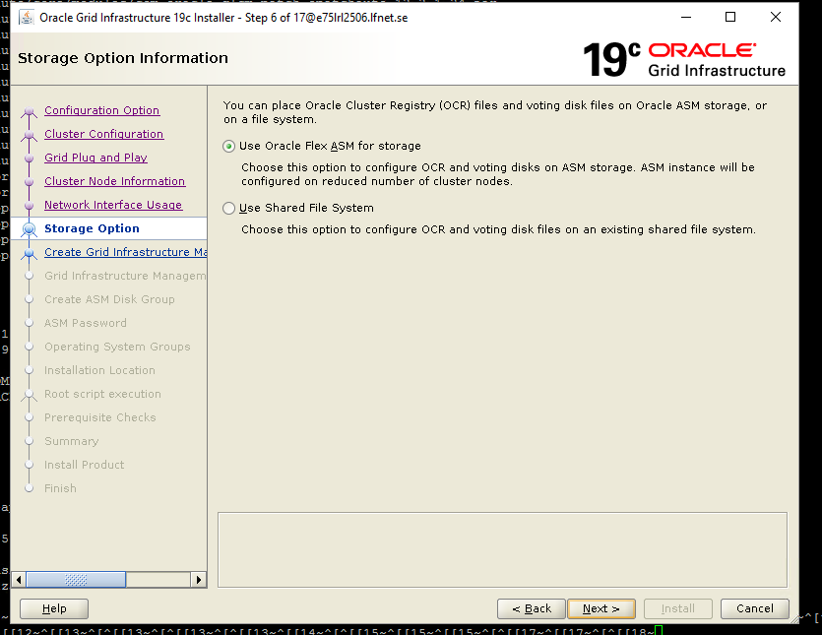

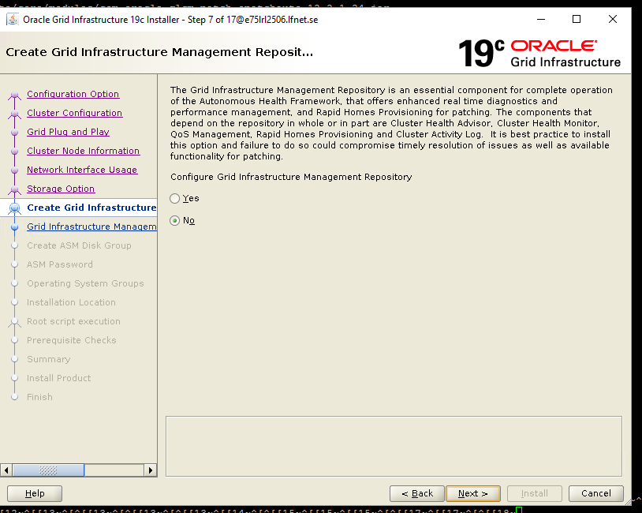

Choose Yes for above screenshot as in production we have management repository.
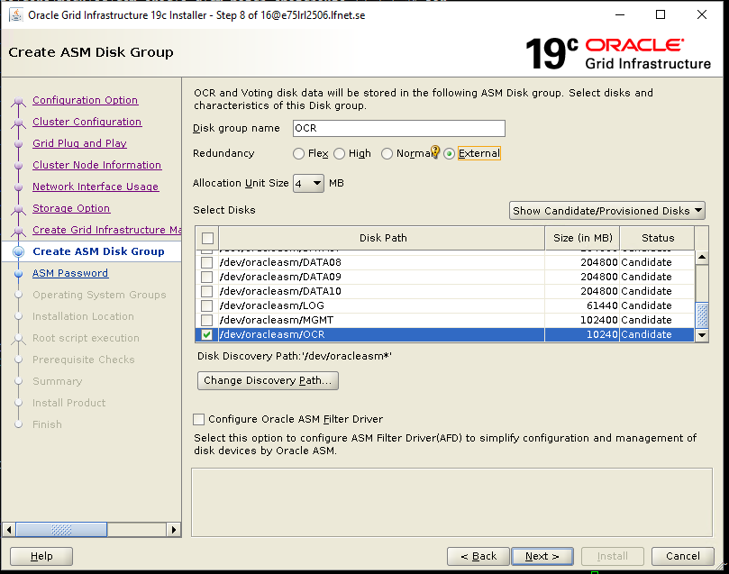

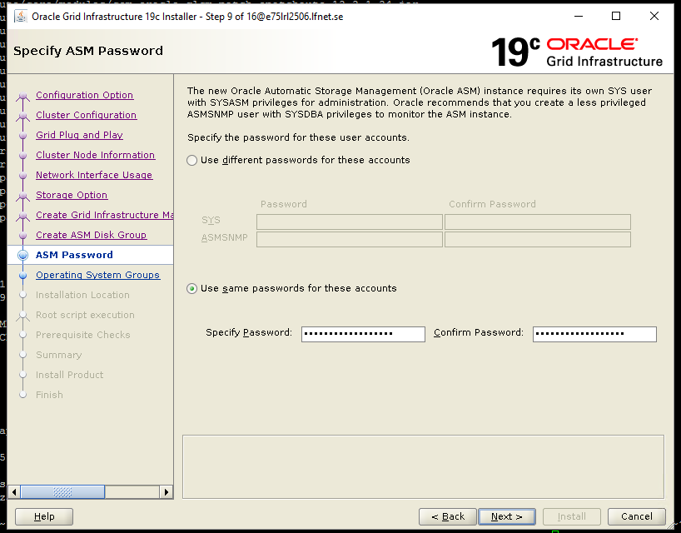

Sys password - SySpasSWord2506Sys

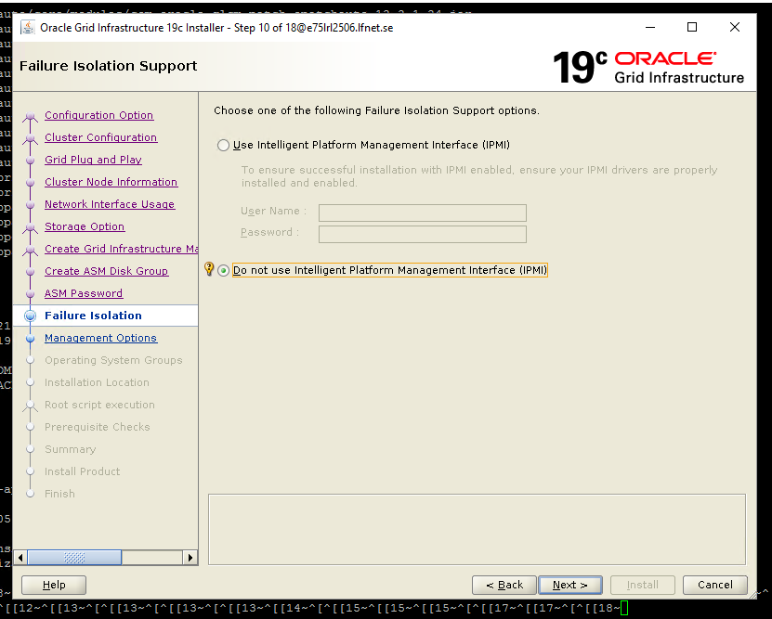

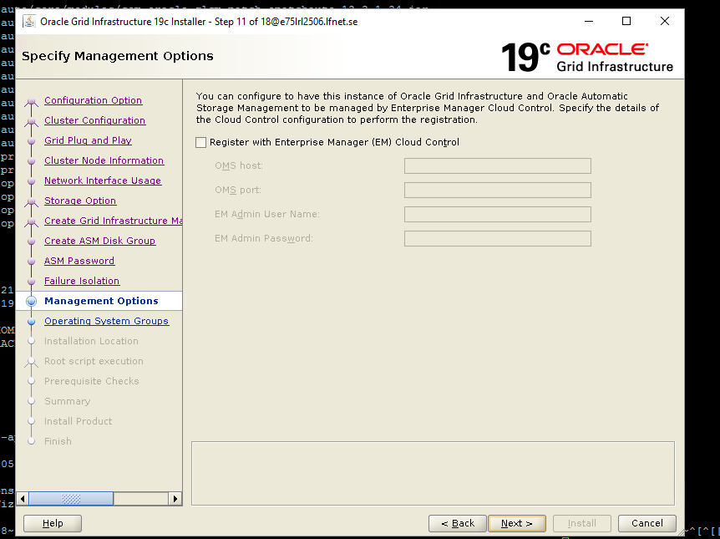

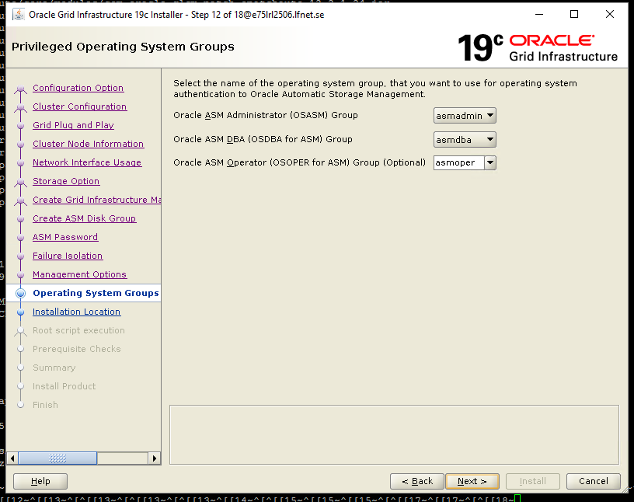

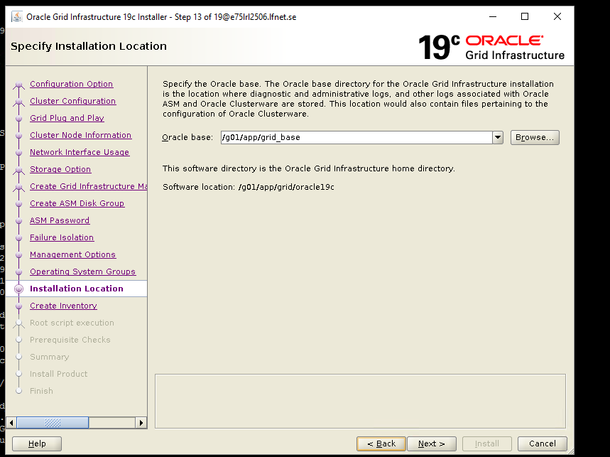

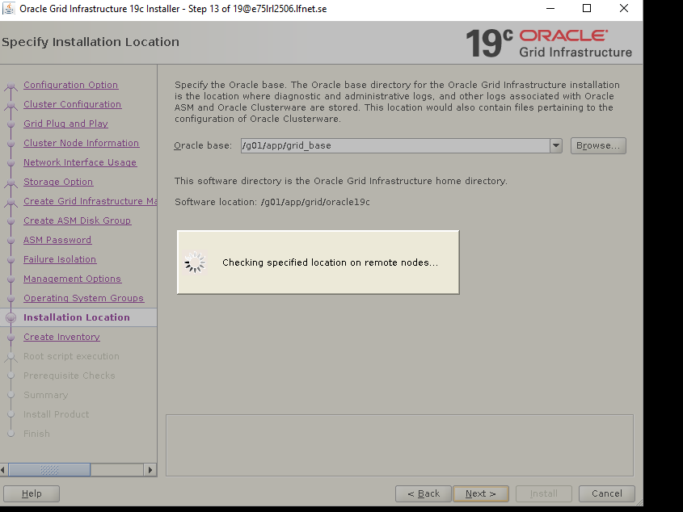

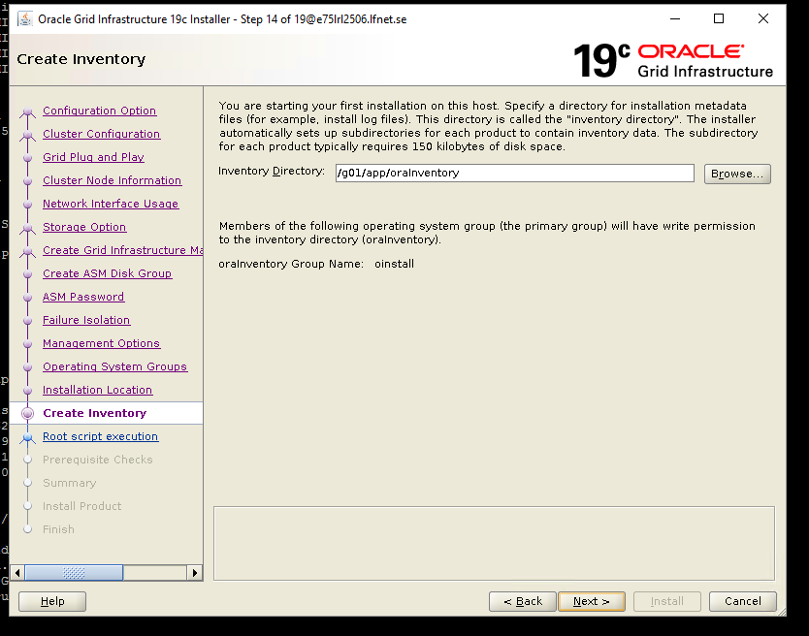

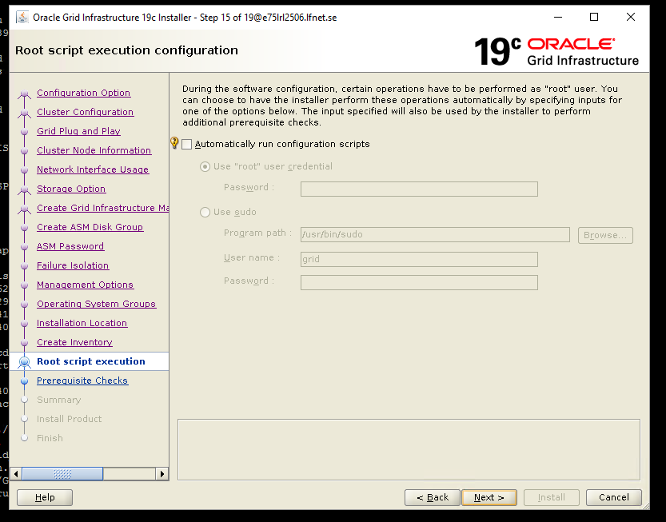

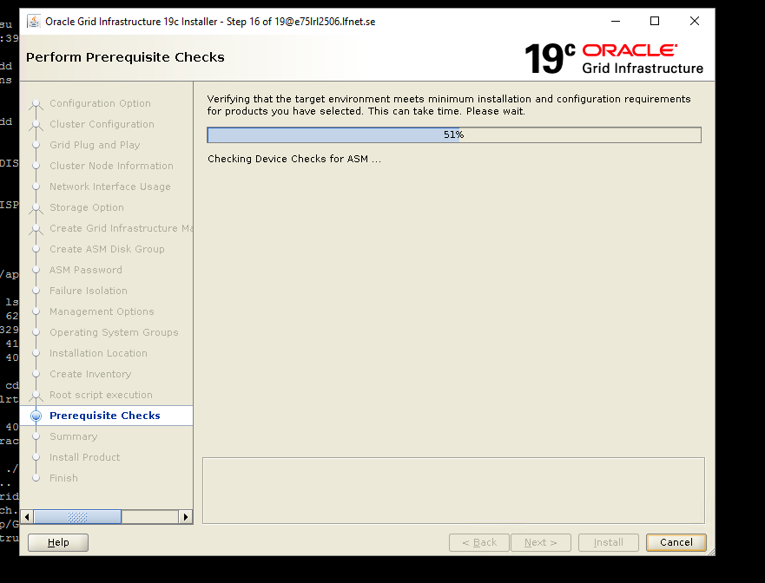

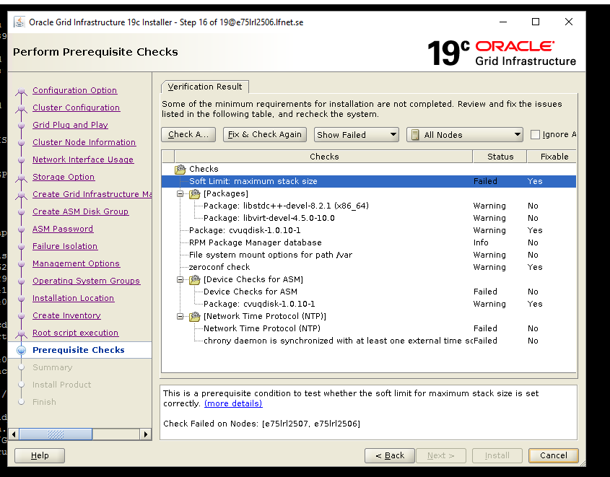

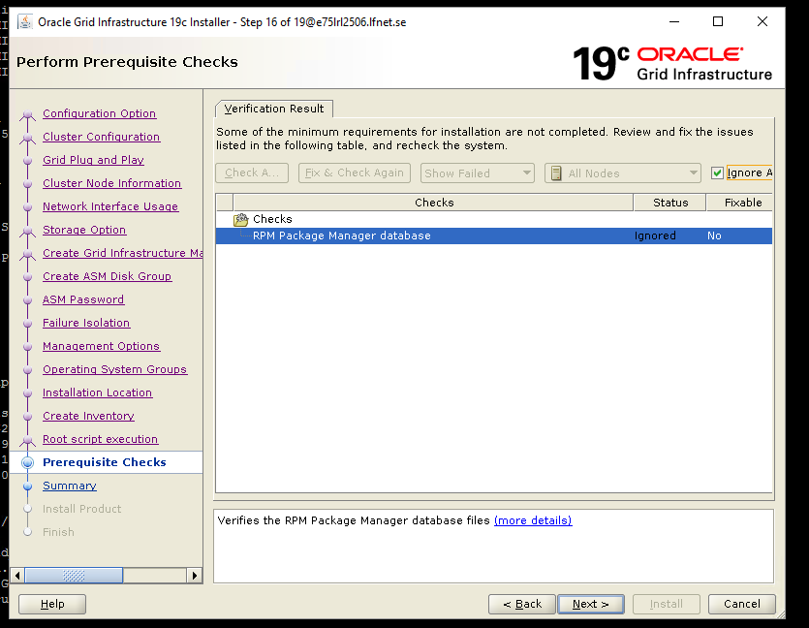

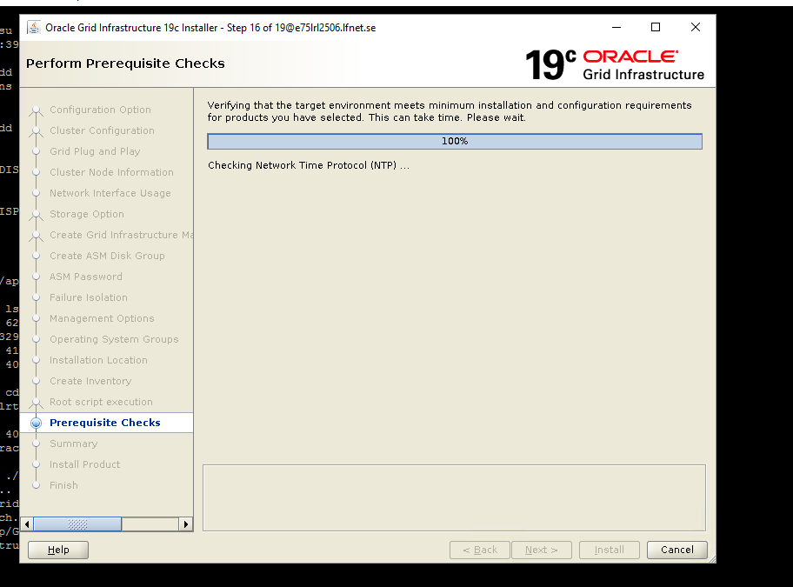

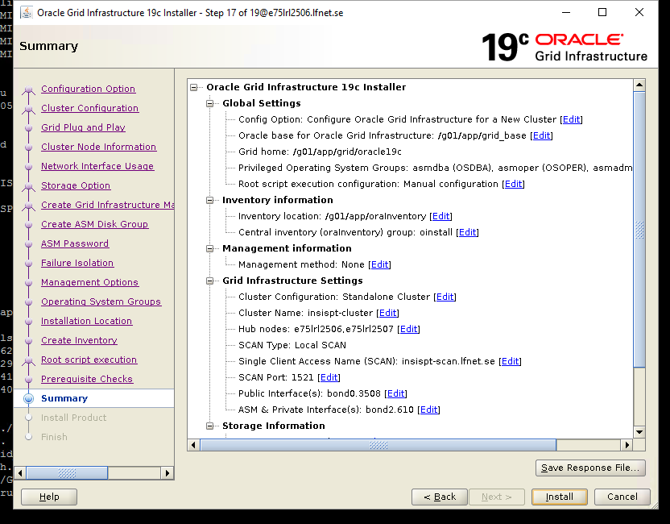

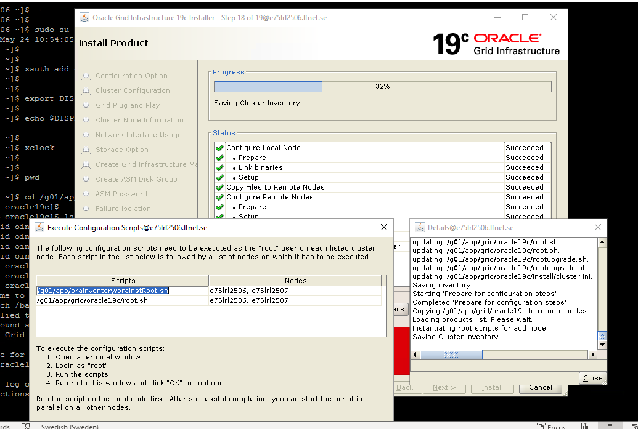
On 2506 –
1st script execution -
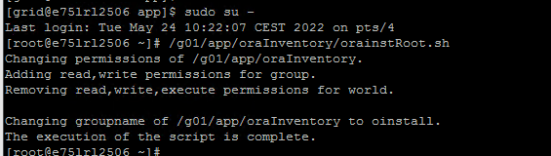

2nd script execution –
[root@e75lrl2506 ~]# /g01/app/grid/oracle19c/root.sh
Performing root user operation.

The following environment variables are set as:
ORACLE_OWNER= grid
ORACLE_HOME= /g01/app/grid/oracle19c

Enter the full pathname of the local bin directory: [/usr/local/bin]:
Copying dbhome to /usr/local/bin ...
Copying oraenv to /usr/local/bin ...
Copying coraenv to /usr/local/bin ...

Creating /etc/oratab file...
Entries will be added to the /etc/oratab file as needed by
Database Configuration Assistant when a database is created
Finished running generic part of root script.
Now product-specific root actions will be performed.
Relinking oracle with rac_on option
Using configuration parameter file: /g01/app/grid/oracle19c/crs/install/crsconfig_params
The log of current session can be found at:
/g01/app/grid_base/crsdata/e75lrl2506/crsconfig/rootcrs_e75lrl2506_2022-05-24_11-20-11AM.log
2022/05/24 11:20:19 CLSRSC-594: Executing installation step 1 of 19: 'SetupTFA'.
2022/05/24 11:20:19 CLSRSC-594: Executing installation step 2 of 19: 'ValidateEnv'.
2022/05/24 11:20:19 CLSRSC-363: User ignored prerequisites during installation
2022/05/24 11:20:19 CLSRSC-594: Executing installation step 3 of 19: 'CheckFirstNode'.
2022/05/24 11:20:21 CLSRSC-594: Executing installation step 4 of 19: 'GenSiteGUIDs'.
2022/05/24 11:20:22 CLSRSC-594: Executing installation step 5 of 19: 'SetupOSD'.
2022/05/24 11:20:22 CLSRSC-594: Executing installation step 6 of 19: 'CheckCRSConfig'.
2022/05/24 11:20:22 CLSRSC-594: Executing installation step 7 of 19: 'SetupLocalGPNP'.
2022/05/24 11:20:31 CLSRSC-594: Executing installation step 8 of 19: 'CreateRootCert'.
2022/05/24 11:20:35 CLSRSC-594: Executing installation step 9 of 19: 'ConfigOLR'.
2022/05/24 11:20:47 CLSRSC-594: Executing installation step 10 of 19: 'ConfigCHMOS'.
2022/05/24 11:20:47 CLSRSC-594: Executing installation step 11 of 19: 'CreateOHASD'.
2022/05/24 11:20:52 CLSRSC-594: Executing installation step 12 of 19: 'ConfigOHASD'.
2022/05/24 11:20:52 CLSRSC-330: Adding Clusterware entries to file 'oracle-ohasd.service'
2022/05/24 11:21:12 CLSRSC-594: Executing installation step 13 of 19: 'InstallAFD'.
2022/05/24 11:21:12 CLSRSC-594: Executing installation step 14 of 19: 'InstallACFS'.
2022/05/24 11:21:17 CLSRSC-594: Executing installation step 15 of 19: 'InstallKA'.
2022/05/24 11:21:22 CLSRSC-594: Executing installation step 16 of 19: 'InitConfig'.
Redirecting to /bin/systemctl restart rsyslog.service
2022/05/24 11:21:52 CLSRSC-4002: Successfully installed Oracle Trace File Analyzer (TFA) Collector.

ASM has been created and started successfully.

[DBT-30001] Disk groups created successfully. Check /g01/app/grid_base/cfgtoollogs/asmca/asmca-220524AM112156.log for details.

2022/05/24 11:22:39 CLSRSC-482: Running command: '/g01/app/grid/oracle19c/bin/ocrconfig -upgrade grid oinstall'
CRS-4256: Updating the profile
Successful addition of voting disk 6b74611687d24f2fbfca8201f383b3fb.
Successfully replaced voting disk group with +OCR.
CRS-4256: Updating the profile
CRS-4266: Voting file(s) successfully replaced
## STATE File Universal Id File Name Disk group
-- ----- ----------------- --------- ---------
1. ONLINE 6b74611687d24f2fbfca8201f383b3fb (/dev/oracleasm/OCR) [OCR]
Located 1 voting disk(s).
2022/05/24 11:23:28 CLSRSC-594: Executing installation step 17 of 19: 'StartCluster'.
2022/05/24 11:24:24 CLSRSC-343: Successfully started Oracle Clusterware stack
2022/05/24 11:24:25 CLSRSC-594: Executing installation step 18 of 19: 'ConfigNode'.
2022/05/24 11:25:27 CLSRSC-594: Executing installation step 19 of 19: 'PostConfig'.
2022/05/24 11:25:43 CLSRSC-325: Configure Oracle Grid Infrastructure for a Cluster ... succeeded
[root@e75lrl2506 ~]#

ON 2507 –
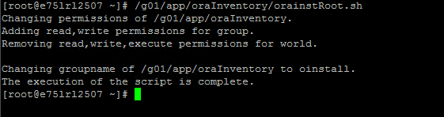

[root@e75lrl2507 ~]# /g01/app/grid/oracle19c/root.sh
Performing root user operation.

The following environment variables are set as:
ORACLE_OWNER= grid
ORACLE_HOME= /g01/app/grid/oracle19c

Enter the full pathname of the local bin directory: [/usr/local/bin]:
Copying dbhome to /usr/local/bin ...
Copying oraenv to /usr/local/bin ...
Copying coraenv to /usr/local/bin ...

Creating /etc/oratab file...
Entries will be added to the /etc/oratab file as needed by
Database Configuration Assistant when a database is created
Finished running generic part of root script.
Now product-specific root actions will be performed.
Relinking oracle with rac_on option
Using configuration parameter file: /g01/app/grid/oracle19c/crs/install/crsconfig_params
The log of current session can be found at:
/g01/app/grid_base/crsdata/e75lrl2507/crsconfig/rootcrs_e75lrl2507_2022-05-24_11-19-23AM.log
2022/05/24 11:19:27 CLSRSC-594: Executing installation step 1 of 19: 'SetupTFA'.
2022/05/24 11:19:27 CLSRSC-594: Executing installation step 2 of 19: 'ValidateEnv'.
2022/05/24 11:19:27 CLSRSC-363: User ignored prerequisites during installation
2022/05/24 11:19:27 CLSRSC-594: Executing installation step 3 of 19: 'CheckFirstNode'.
2022/05/24 11:19:28 CLSRSC-507: The root script cannot proceed on this node e75lrl2507 because either the first-node operations have not completed on node e75lrl2506 or there was an error in obtaining the status of the first-node operations.
Died at /g01/app/grid/oracle19c/crs/install/crsutils.pm line 4628.
[root@e75lrl2507 ~]# 2022/05/24 11:20:53 CLSRSC-4002: Successfully installed Oracle Trace File Analyzer (TFA) Collector.
^C
[root@e75lrl2507 ~]#
[root@e75lrl2507 ~]# /g01/app/grid/oracle19c/root.sh
Performing root user operation.

The following environment variables are set as:
ORACLE_OWNER= grid
ORACLE_HOME= /g01/app/grid/oracle19c

Enter the full pathname of the local bin directory: [/usr/local/bin]:
The contents of "dbhome" have not changed. No need to overwrite.
The contents of "oraenv" have not changed. No need to overwrite.
The contents of "coraenv" have not changed. No need to overwrite.

Entries will be added to the /etc/oratab file as needed by
Database Configuration Assistant when a database is created
Finished running generic part of root script.
Now product-specific root actions will be performed.
Relinking oracle with rac_on option
Using configuration parameter file: /g01/app/grid/oracle19c/crs/install/crsconfig_params
The log of current session can be found at:
/g01/app/grid_base/crsdata/e75lrl2507/crsconfig/rootcrs_e75lrl2507_2022-05-24_11-27-37AM.log
2022/05/24 11:27:41 CLSRSC-594: Executing installation step 1 of 19: 'SetupTFA'.
2022/05/24 11:27:41 CLSRSC-594: Executing installation step 2 of 19: 'ValidateEnv'.
2022/05/24 11:27:41 CLSRSC-363: User ignored prerequisites during installation
2022/05/24 11:27:41 CLSRSC-594: Executing installation step 3 of 19: 'CheckFirstNode'.
2022/05/24 11:27:41 CLSRSC-4002: Successfully installed Oracle Trace File Analyzer (TFA) Collector.
2022/05/24 11:27:42 CLSRSC-594: Executing installation step 4 of 19: 'GenSiteGUIDs'.
2022/05/24 11:27:42 CLSRSC-594: Executing installation step 5 of 19: 'SetupOSD'.
2022/05/24 11:27:42 CLSRSC-594: Executing installation step 6 of 19: 'CheckCRSConfig'.
2022/05/24 11:27:42 CLSRSC-594: Executing installation step 7 of 19: 'SetupLocalGPNP'.
2022/05/24 11:27:43 CLSRSC-594: Executing installation step 8 of 19: 'CreateRootCert'.
2022/05/24 11:27:43 CLSRSC-594: Executing installation step 9 of 19: 'ConfigOLR'.
2022/05/24 11:27:49 CLSRSC-594: Executing installation step 10 of 19: 'ConfigCHMOS'.
2022/05/24 11:28:20 CLSRSC-594: Executing installation step 11 of 19: 'CreateOHASD'.
2022/05/24 11:28:21 CLSRSC-594: Executing installation step 12 of 19: 'ConfigOHASD'.
2022/05/24 11:28:21 CLSRSC-330: Adding Clusterware entries to file 'oracle-ohasd.service'
2022/05/24 11:28:36 CLSRSC-594: Executing installation step 13 of 19: 'InstallAFD'.
2022/05/24 11:28:36 CLSRSC-594: Executing installation step 14 of 19: 'InstallACFS'.
2022/05/24 11:28:37 CLSRSC-594: Executing installation step 15 of 19: 'InstallKA'.
2022/05/24 11:28:38 CLSRSC-594: Executing installation step 16 of 19: 'InitConfig'.
Redirecting to /bin/systemctl restart rsyslog.service
2022/05/24 11:28:46 CLSRSC-594: Executing installation step 17 of 19: 'StartCluster'.
2022/05/24 11:29:33 CLSRSC-343: Successfully started Oracle Clusterware stack
2022/05/24 11:29:33 CLSRSC-594: Executing installation step 18 of 19: 'ConfigNode'.
2022/05/24 11:29:41 CLSRSC-594: Executing installation step 19 of 19: 'PostConfig'.
2022/05/24 11:29:44 CLSRSC-325: Configure Oracle Grid Infrastructure for a Cluster ... succeeded
[root@e75lrl2507 ~]#

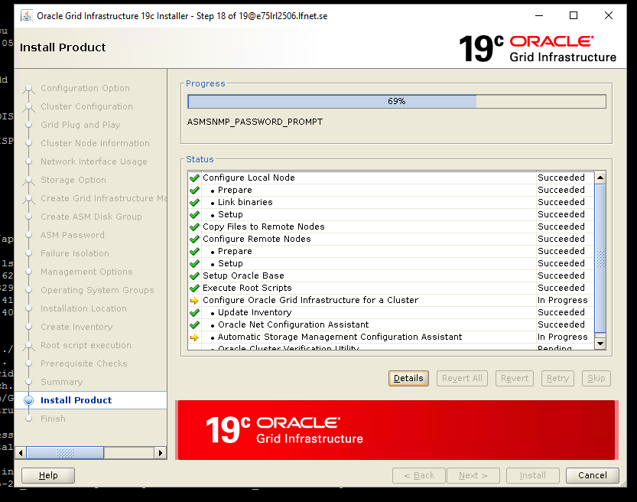

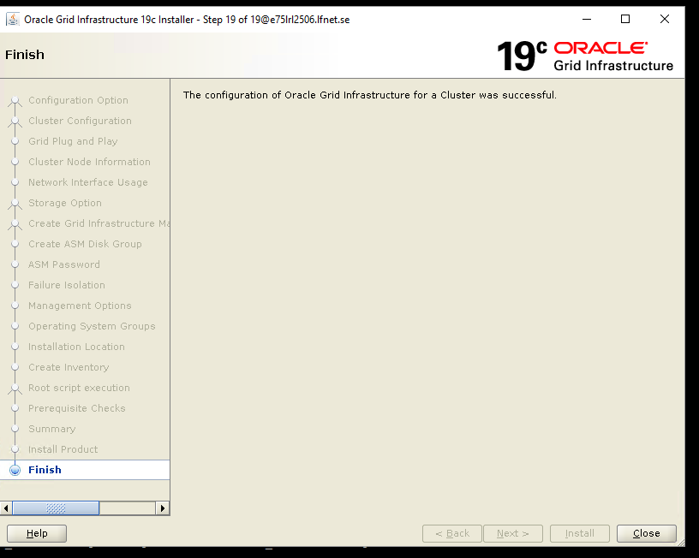
Click cLose
Check ASM processes on both nodes-
Should be able to see +ASM1 and +ASM2
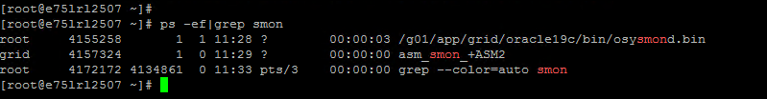

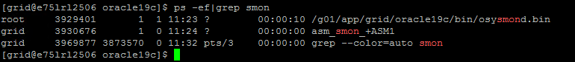

Edit oratab file on both nodes - Make entry for +ASM1 and INSISPT1
+ASM2 and INSISPT2

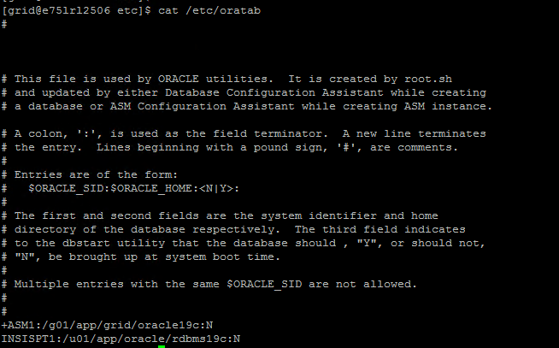

Set env variable of ASM istance via oraenv and
Check crs services on both nodes –
2506 -
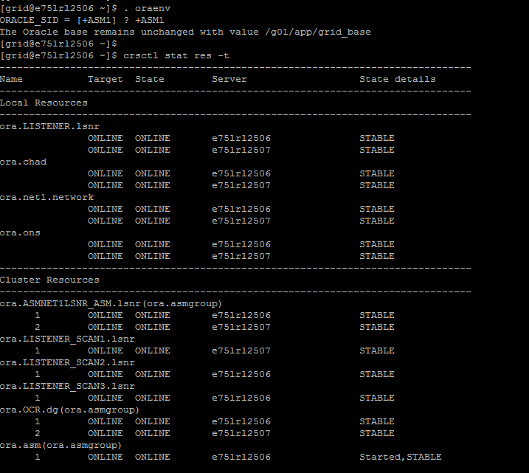

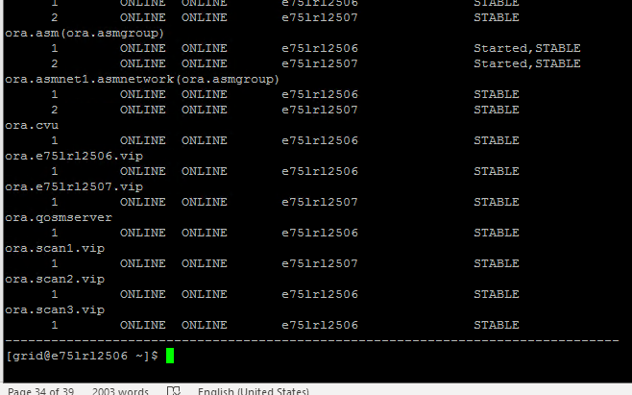

On 2507 -
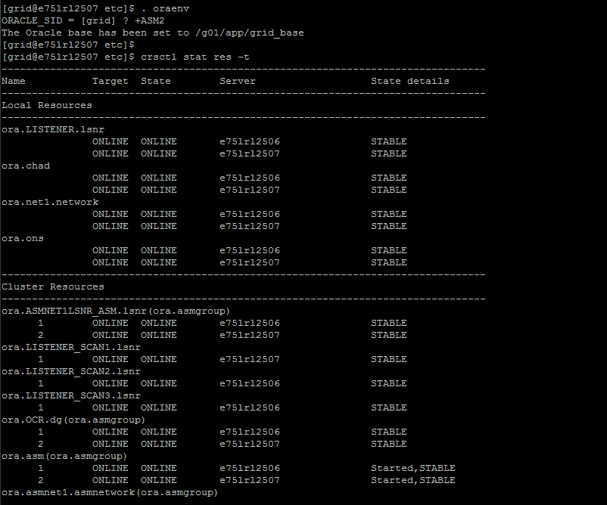

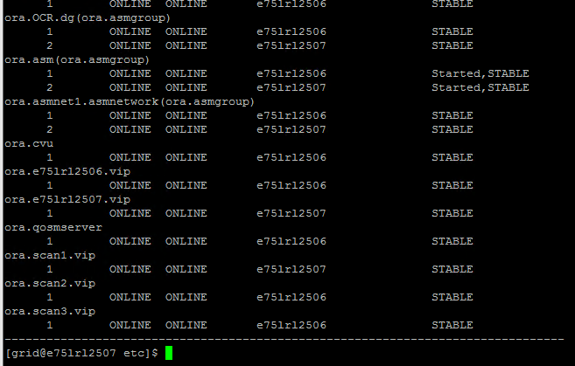

Creating ASM Diskgroup using ASMCA Tool for database creation:
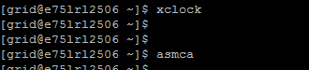

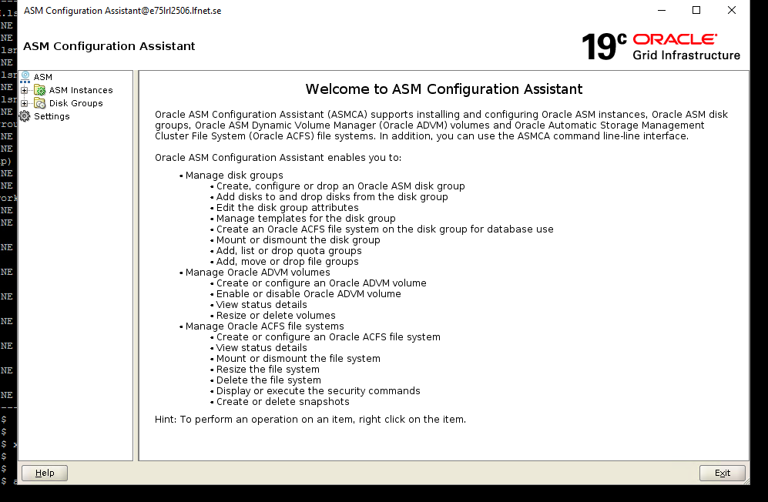

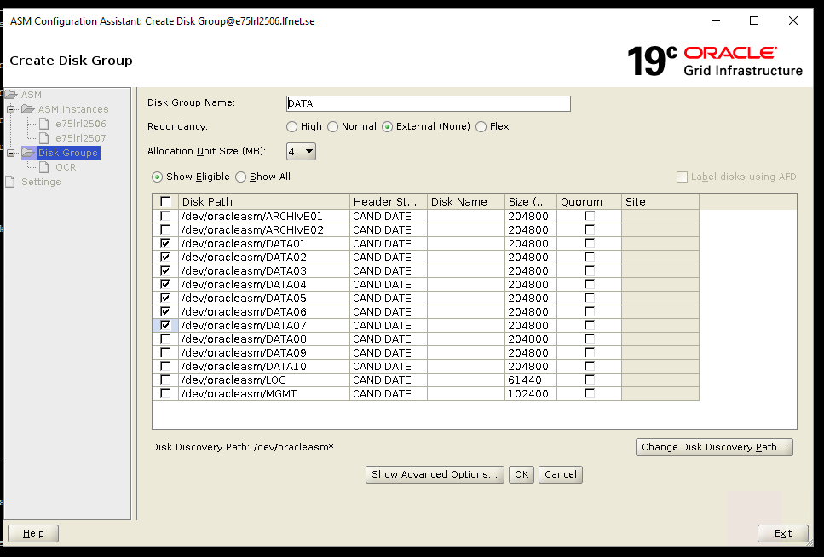

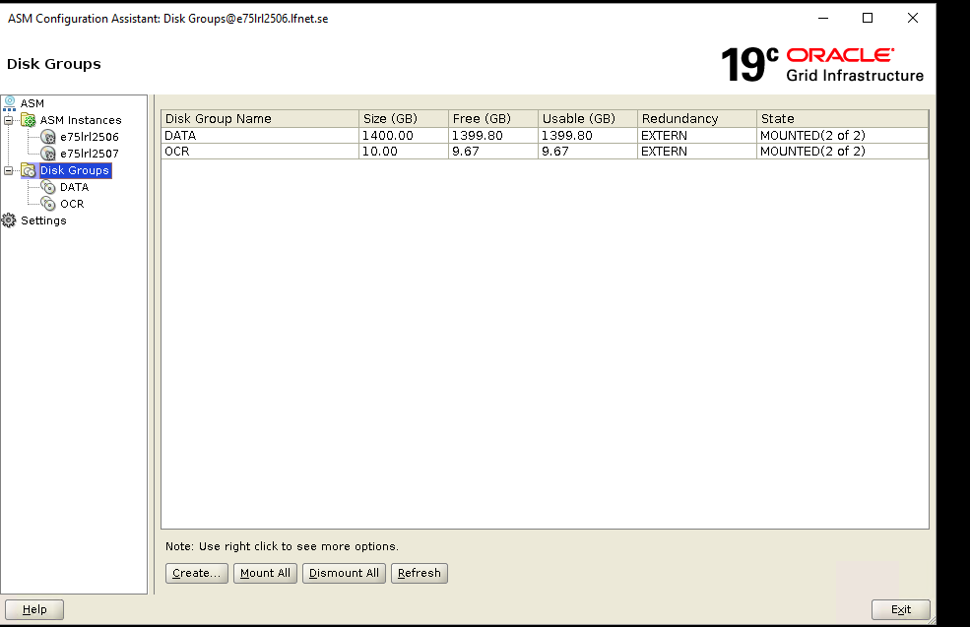

Click create to create disk group for Archives

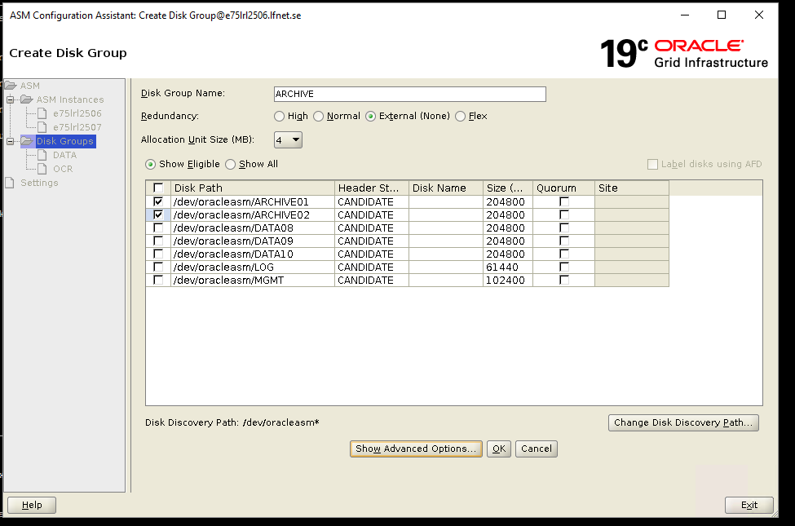

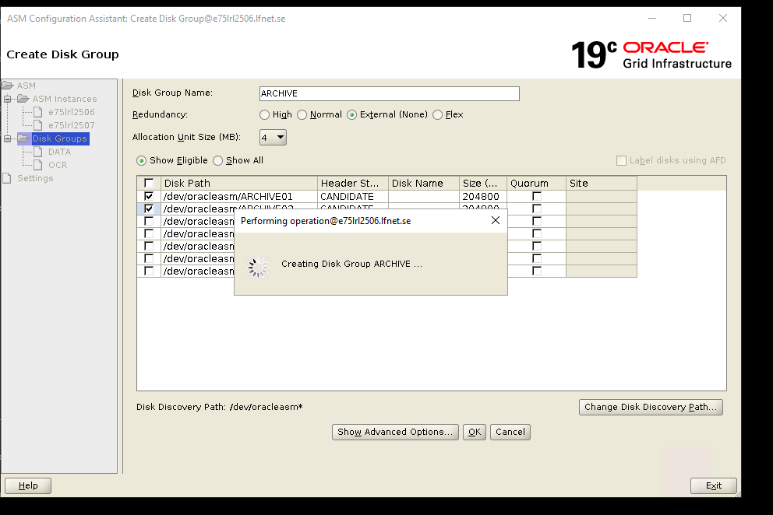

Click create and Create disk group for redo log

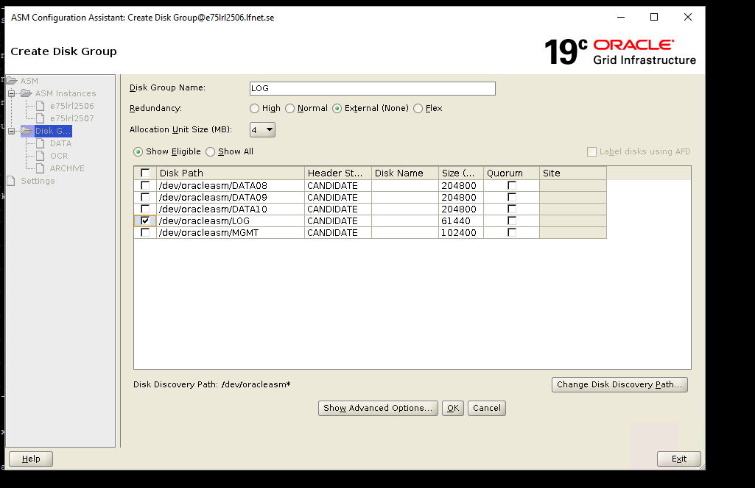

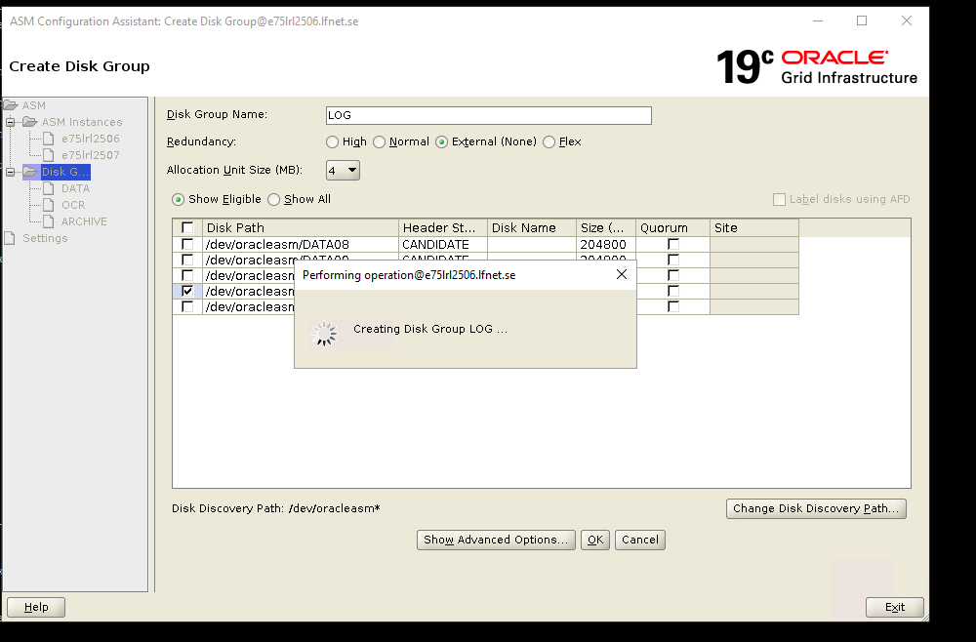

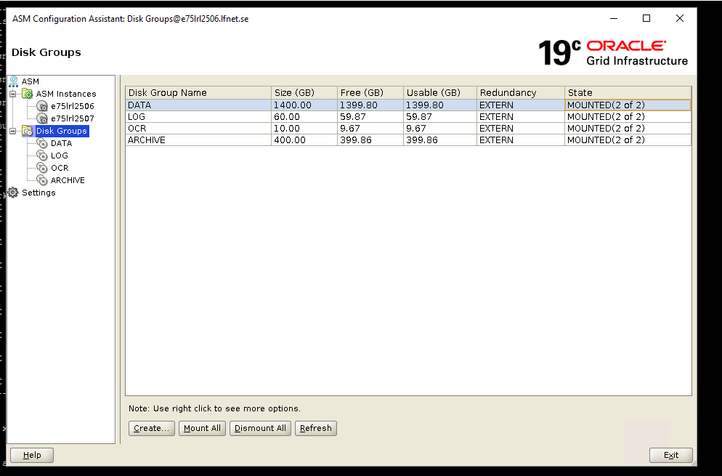

Exit installer

Check asm disk groups –

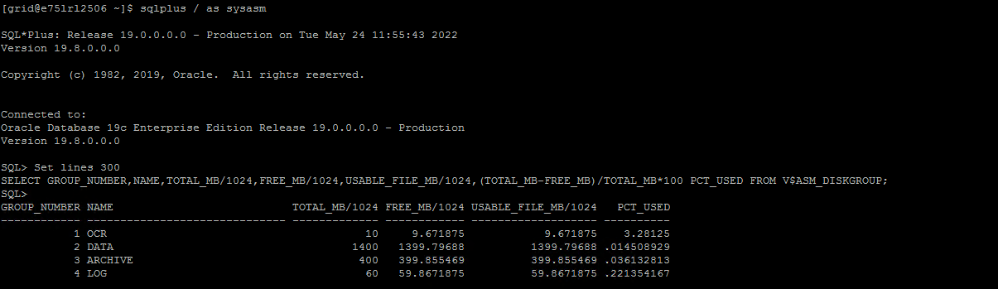

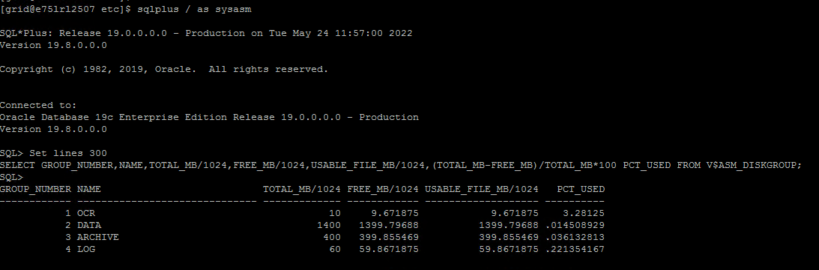

Install require packages using yum install –

[root@e75lrl2506 ~]# yum install libstdc++-devel-8.2.1
Updating Subscription Management repositories.
Unable to read consumer identity

This system is not registered with an entitlement server. You can use subscription-manager to register.

Last metadata expiration check: 4:08:22 ago on Fri 20 May 2022 11:01:32 AM CEST.
Dependencies resolved.
===============================================================================================================================================================
Package Architecture Version Repository Size
===============================================================================================================================================================
Installing:
libstdc++-devel x86_64 8.2.1-3.5.el8 RHEL8-----Local----Repository-APP-----HCL-LFAB 2.0 M
Downgrading:
libstdc++ x86_64 8.2.1-3.5.el8 RHEL8-----Local----Repository-BASE-----HCL-LFAB 448 k

Transaction Summary
===============================================================================================================================================================
Install 1 Package
Downgrade 1 Package

Total download size: 2.5 M
Is this ok [y/N]: y
Downloading Packages:
(1/2): libstdc++-8.2.1-3.5.el8.x86_64.rpm 25 MB/s | 448 kB 00:00
(2/2): libstdc++-devel-8.2.1-3.5.el8.x86_64.rpm 62 MB/s | 2.0 MB 00:00
---------------------------------------------------------------------------------------------------------------------------------------------------------------
Total 71 MB/s | 2.5 MB 00:00
Running transaction check
Transaction check succeeded.
Running transaction test
Transaction test succeeded.
Running transaction
Preparing : 1/1
Downgrading : libstdc++-8.2.1-3.5.el8.x86_64 1/3
Running scriptlet: libstdc++-8.2.1-3.5.el8.x86_64 1/3
Installing : libstdc++-devel-8.2.1-3.5.el8.x86_64 2/3
Cleanup : libstdc++-8.5.0-4.el8_5.x86_64 3/3
Running scriptlet: libstdc++-8.5.0-4.el8_5.x86_64 3/3
Verifying : libstdc++-8.2.1-3.5.el8.x86_64 1/3
Verifying : libstdc++-8.5.0-4.el8_5.x86_64 2/3
Verifying : libstdc++-devel-8.2.1-3.5.el8.x86_64 3/3
Installed products updated.

Downgraded:
libstdc++-8.2.1-3.5.el8.x86_64
Installed:
libstdc++-devel-8.2.1-3.5.el8.x86_64

Complete!
[root@e75lrl2506 ~]#

Screenshot below –
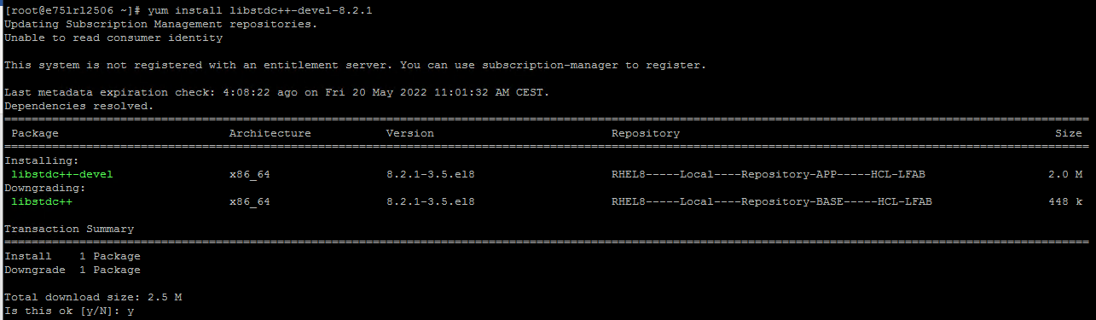

Enter Y

